## **Project “Dank Souls” 1-Page GDD**

*3rd Person Dark Souls from a stoned perspective*

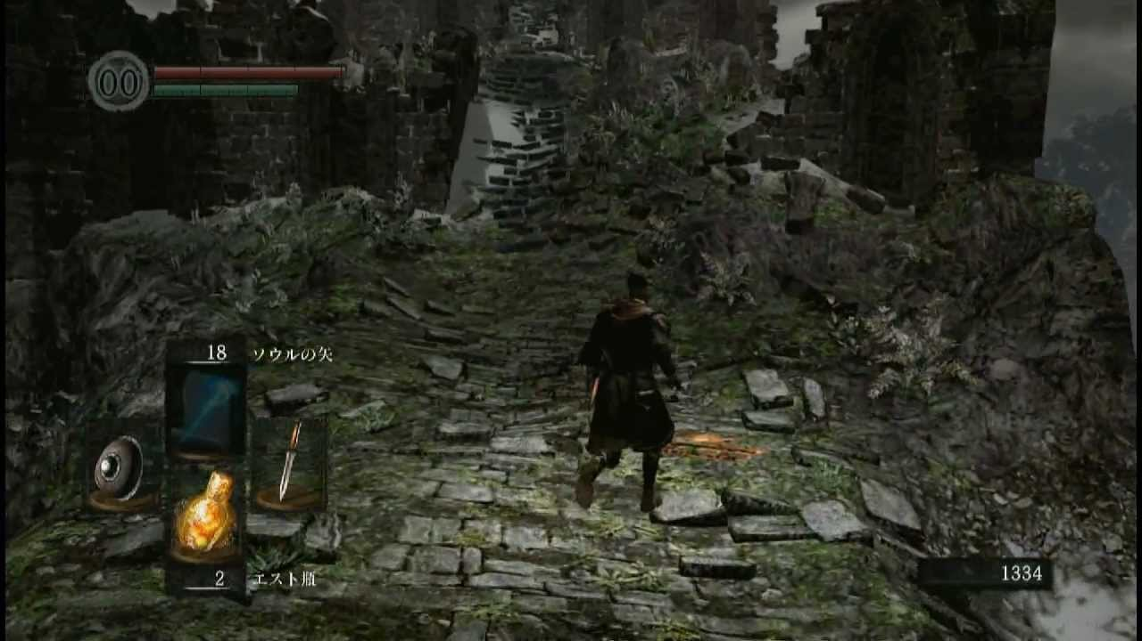+

**Genre:** Action-RPG. 3rd Person fixed camera  
**Target Audience:** T for Teen

**Controls:** Mouse & Keyboard, GamePad

**Thematic Setting:** Mediaval Fantasy

**Tech Stack:** Unity 5+, Blender, Gimp , Audacity

**Platform(s):** Steam

**Game Moment:**

**Game Summary:**

**Core Player Experience:**

**Central Theme:**

**Design Pillar:**

**Anticipated Remarkability:**

**Anticipated Steam Early Access Launch date:**

**Feature Development Priorities:**

**Comparative Products:**